**dbo.createUserStat**

**SQL**

CREATE OR ALTER PROCEDURE dbo.createUserStat  
(  
    @Schema sysname = 'dbo', --Specific Schema default to dbo  
    @TableList VARCHAR(8000) NULL,  -- All under Schema or specific list  
    @FullScan bit = 0,  
    @SamplePercent int = 0  
)  
AS  
  
SELECT  
schemas.name as Schema_Name, tables.name as Table_Name, columns.name as Column_Name,   
    'CREATE STATISTICS [' + schemas.name + '_' +  tables.name + '_' + columns.name + '_stat] ON [' + schemas.name + '].[' + tables.name + '] ([' + columns.name + '])  ' +  
    CASE   
        WHEN @FullScan = 1 THEN ' WITH FULLSCAN'  
        WHEN @SamplePercent > 0 THEN CONCAT('WITH SAMPLE ', @SamplePercent, ' PERCENT')  
        ELSE ''  
    END    AS Query  
FROM  
    sys.schemas  
    INNER JOIN sys.objects as tables  
        ON ([schemas].[schema_id] = [tables].[schema_id])  
    INNER JOIN sys.columns  
        ON ([tables].[object_id] = [columns].[object_id])  
    LEFT JOIN (SELECT LTRIM(RTRIM([value])) FROM STRING_SPLIT(@TableList, ',')) AS [table_list] ([name])  
        ON ([tables].[name] = [table_list].[name])  
    LEFT JOIN sys.stats_columns  
        ON ([columns].[object_id] = [stats_columns].[object_id])  
        AND ([columns].[column_id] = [stats_columns].[column_id])  
    LEFT JOIN sys.stats  
        ON ([stats_columns].[object_id] = [stats].[object_id])  
        AND [stats].[user_created] != 0  
WHERE  
    [schemas].name = @Schema  
    AND ((@TableList IS NULL) OR ([table_list].[name] IS NOT NULL))  
    --AND ([stats_columns].[stats_id] IS NULL) -- Include only columns that do not already have existing statistics on them ( WE DO WANT TO CREATE NEW STATS  
    AND ([stats].[stats_id] IS NULL)  
GROUP BY tables.name, schemas.name, columns.name;  
GO

Expand (38 lines)

Example Exeuction of the Sproc - will generate the SQL Code to create user defined Stats per column based on the input Parameters

@Schema = Allows you to specific a Single target Schema

@TableList = Allows for more grainular control into which tables within the above Schema that you want to apply Stats to.  Example can be Null, 'dim_customer', or 'dim_customer, dim_table1, dim_tableN'

@FullScan is a Boolean paramater, determining if you want to apply the WITH FULLSCAN option

@SamplePercent is an Integer parameter, allowing you to specify the Sample % that you want, for example, if I pass in 10, will append 'WITH SAMPLE 10 PERCENT'.  0 is the default value and this option will only be applied with @FullScan = 0 and @SamplePercent is greater than 0

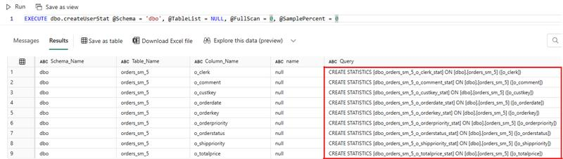

The Data Pipeline

The process for the Data Pipeline will be to

1. Script Activity to Call the dbo.createUserStat stored procedure
   1. Note: Can make parameters dynamic

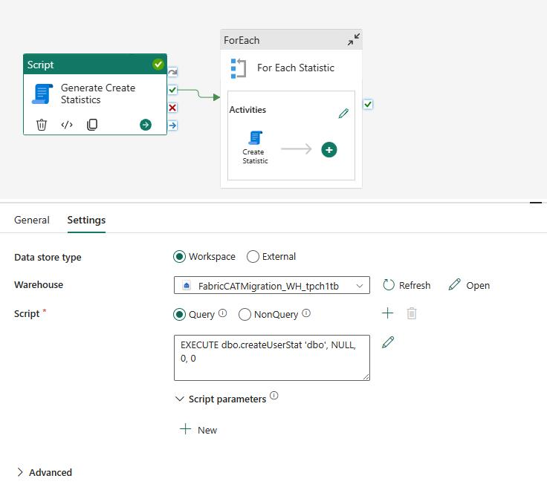

1. ForEach Activity referencing the output of the Script Activity - non-sequential with 50 specified as the Batch count
   1. @activity('Generate Create Statistics').output.resultSets[0].rows
2. Within the ForEach, I have another Script Activity that will run the dynamically generated SQL statement

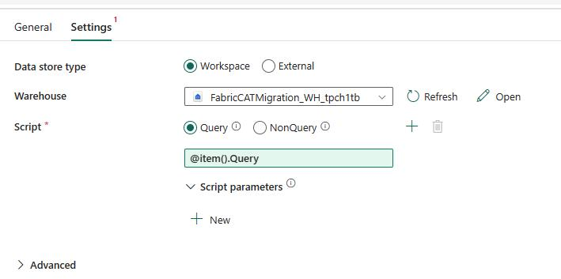

Example

I ran this for a newly created table that has 9 columns. We can see that the Pipeline Ran with 9 ForEach Iterations

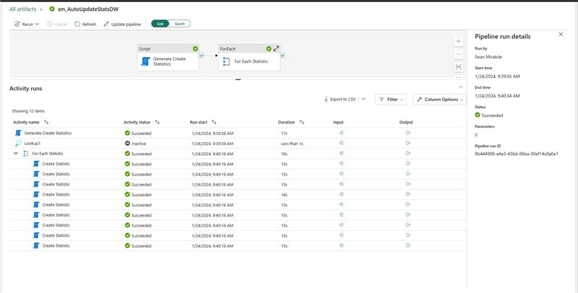

You can see the Output of the Script Activity contains a row[] for each row returned by the Warehouse

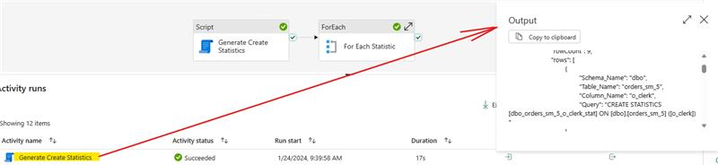

Here is the Pipeline Definition